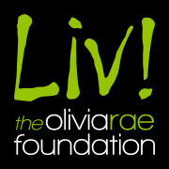
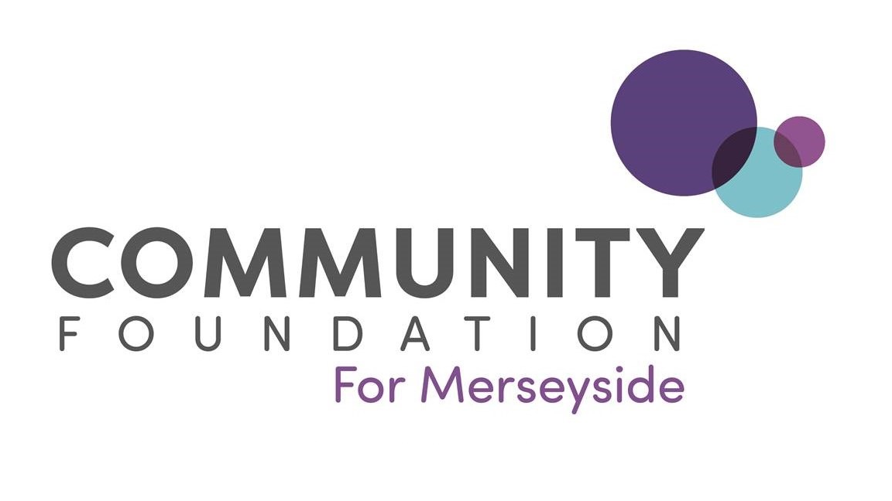

The Olivia Rae Foundation

Background Information
The Olivia Rae Foundation has been established by the family of Olivia Rae Clee-Barnett from Wirral, in loving memory of their daughter.

What is the focus of the fund?
The Foundation aims to support local young people to realise and develop their potential by undertaking new opportunities and activities that they may not otherwise have the chance to take part in. The family wishes to focus on supporting individuals who are suffering financial hardship or groups working within deprived communities.

Applications are welcome from those based in Merseyside that meet one or more of the following priorities:

- Projects that have long term strategic aims, e.g. participation in courses or workshops that will enable a young person/young people to work towards a longer-term dream, ambition or plan.
- Projects that explore the positive potential of bringing communities together, either from the perspective of or for the benefit of young people
- Applications that have an emphasis on ‘the arts’ and/or those that focus on educating young people in life skills and experiences rather than more formal style education.

How much is available?
The maximum grant available is £500 for individuals and £1,000 for groups

Who can apply?
Young people aged between 11 and 24 years of age.
Projects that target young people aged between 11 and 25 years of age.

Which areas are covered?
Merseyside, although priority will be given to applicants from Wirral.

Examples of the sorts of projects that may be funded:
Funds towards courses, competitions or resources for dance, music, drama and other forms of arts activities.

How to apply?
Please email michaela.kenney@cflm.org.uk to request an Expression of Interest form. You will also need to send the documents listed below, which can be emailed back to Michaela with your completed form. Alternatively, you can email them to applications@cflm.org.uk or post them to the address below. If you do not submit all the relevant documents within seven days, your application will be withdrawn.

Documents that need to be included with your application:

For Individuals
- Proof of residence is required to be sent with your application (a copy of a utility bill/driving licence or other similar document stating your home address)
- A copy of a recent bank statement (if you do not have your own bank account, please provide the name and address of a person over 18 years of age who is willing to receive payment on your behalf along with a copy of their bank statement)
- If your application is for course or competition fees, please submit the following information with your application: a letter of acceptance/support from the course provider, sports institution, college etc.

For Groups
- Governing Document
- Annual accounts
- Safeguarding policy
- Your organisation’s bank statement dated within the last three months
- List of management commitment/trustees/directors

The following cannot be supported via the fund:
- National organisations that cannot demonstrate local governance and control of local finances
- Statutory organisations or work that is their responsibility
- CICs limited by shares (unless the governing document expressly states no dividends or bonuses are issued to shareholders).
- Organisations with less than three unrelated trustees/directors/management committee members
- Commercial ventures
- Purchase/maintenance of vehicles
- Activities that will have already taken place before we offer you a grant
- Politically connected or exclusively religious activities
- Projects for personal profit
- Organisations that are set up for the benefit of animals or plants; environmental groups that work with animals or the environment (such as city farms) are acceptable
- Debts and other liabilities
- Reclaimable VAT
- Travel outside UK

How are decisions made?
Completed applications are considered by Community Foundation staff to check eligibility and you may be contacted for more information after applying. The application will be shared with representatives from the Olivia Rae Foundation who will make recommendations based on the fund’s criteria and the budget available.

For further information, please contact Michaela Kenney, Senior Programmes Executive at:

Community Foundation for Merseyside
Third Floor
Stanley Building
43 Hanover Street
Liverpool
L1 3DN
T: 0151 294 4756
Email: michaela.kenney@cflm.org.uk

